|  |  |  |
| --- | --- | --- |
| **CFB-PROCEDURE** | **Document** | **BABER0003** |
| ***GrowthProfiler***  ***Yeast OD/G-value standard curve (Delft medium)*** | **Revision no** | **Draft 1** |
| **Revision data** | **06-03-2014** |
| **Author** | **BABER** |
| **Pages** | **1 of 2** |

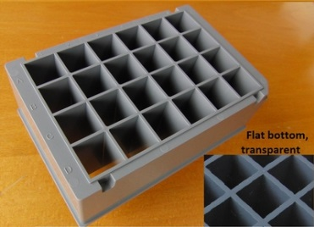

**B**

**A**

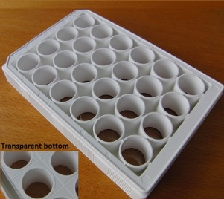**Material**

* 8 shake flasks, 250 mL
* 3 24 roundwell microplates (white) (Fig. 1A)
* 1 24 squarewell microplate (grey) (Fig. 1B)
* 4 Falcon tubes, 50 mL
* YPD medium

**Figure 1.**

* Delft medium

**Procedure**

1. Inoculate 8×50 mL of YPD medium with the chosen yeast strain and incubate at 30°C at 180 rpm overnight.
2. Combine the cultures and measure the OD600. This value (*ODinit*), will be used to calculate the actual points used in the calibration curve. The OD of this culture need to be at least 9 to cover a range between OD = 0 and OD = 115.
3. Transfer 50 mL of the culture to a Falcon tube and collect the cells by centrifugation at 4000 rpm for 5 min. Remove the supernatant and repeat until all the cells have been collected. While waiting, add Delft medium to the remaining Falcon tubes according to Table 1.
4. Resuspend the cells in 10 mL Delft medium to make cell suspension D. Prepare a dilution series according to Table 1.  
     
   **Table 1. Dilution series for cell suspensions A-D.**

|  |  |  |  |
| --- | --- | --- | --- |
| Cell suspension | Volume cell suspension | Volume Delft medium (mL) | Final OD |
| D | – | 31.3 | *ODD* = *ODinit* × *V*tot / *V*D = **115** |
| C | 15 mL suspension D | 16.4 | *ODC* = *ODD* × *V*1 / *V*2 = **55** |
| B | 10 mL suspension C | 9.6 | *ODB* = *ODC* × *V*1 / *V*2 = **28** |
| A | 1 mL suspension B | 6.0 | *ODA* = *ODB* × *V*1 / *V*2 = **4** |

1. Transfer the volume of cell suspension given in Table 2 to the corresponding wells in a grey 24 squarewell microplate. Use cell suspension A for row A etc.  
     
   **Table 2. Volume of cell suspension (µL) to be added in each well.**

|  |  |  |  |  |  |  |
| --- | --- | --- | --- | --- | --- | --- |
|  | 1 | 2 | 3 | 4 | 5 | 6 |
| A | 0 | 150 | 310 | 620 | 1250 | 2500 |
| B | 720 | 1070 | 1430 | 1790 | 2140 | 2500 |
| C | 1450 | 1640 | 1820 | 2040 | 2270 | 2500 |
| D | 1410 | 1630 | 1850 | 2060 | 2280 | 2500 |

1. Add Delft medium to each well according to Table 3 to complete the volume to 2.5 mL.  
     
   **Table 3. Volume of Delft medium (µL) to be added in each well.**

|  |  |  |  |  |  |  |
| --- | --- | --- | --- | --- | --- | --- |
|  | 1 | 2 | 3 | 4 | 5 | 6 |
| A | 2500 | 2350 | 2190 | 1880 | 1250 | 0 |
| B | 1780 | 1430 | 1070 | 710 | 360 | 0 |
| C | 1050 | 860 | 680 | 460 | 230 | 0 |
| D | 1090 | 870 | 650 | 440 | 220 | 0 |

1. Transfer 750 µL from each well in the grey microplate to the corresponding well in three separate white 24 roundwell microplates (triplicate readings of each OD). Remember to mix the suspension before transfer.
2. Cover the microplates and place them in the GrowthProfiler. See GrowthProfiler SOP for additional instructions on the equipment.
3. Copy the data to the Excel template to calculate OD-values and to generate the standard curve.